Don’t Panic!  The technology behind the evacuation program |   Mixed Reality Laboratory  Computer Science and IT  University of Nottingham  http://www.mrl.nott.ac.uk/

Underground Station Evacuation Simulator
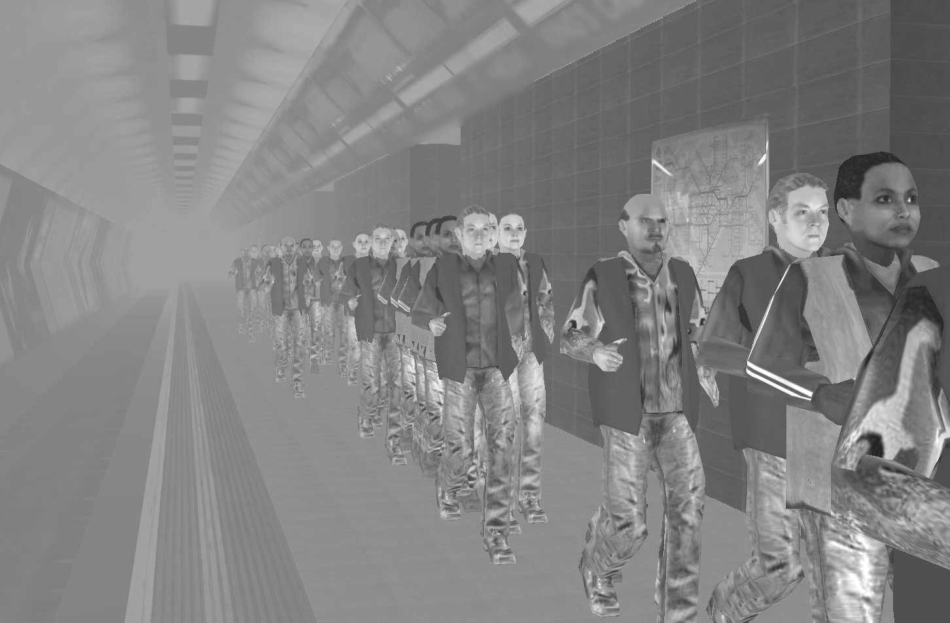
The program allows a user to be placed safely in a stressful evacuation environment, to determine their reactions to other members of the crowd. The scenario can be altered using a series of dropdown menus at the beginning of the program. The options include level of smoke, number of evacuees, speed of crowd movement and inclusion of injured passengers. There are also options to change the psychological perspective of the user by placing them with strangers, or in football crowds, or by playing soundtracks that
make them feel that they are late.

Real-Time Graphics
The graphics behind the evacuation simulation are created using three dimensional Computer Aided Design (CAD) packages similar to those used in both the computer games industry, and to create animated films such as Shrek or The Incredibles. The models are created as a 3D mesh which is later wrapped in (or textured with) photographic images that give the realism achieved in the final models.

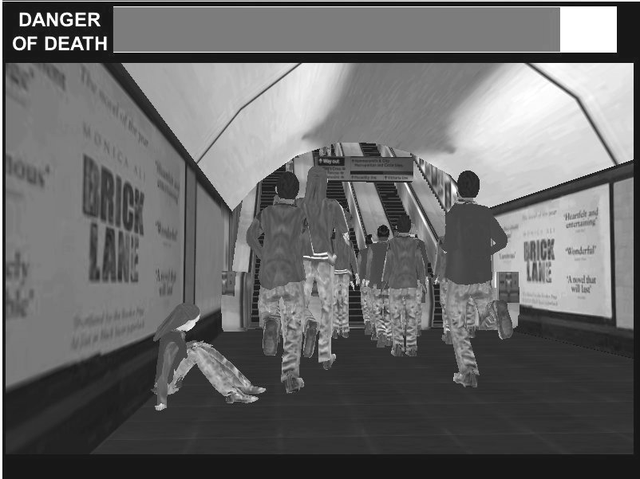
The evacuation environment is in fact more like a 3D computer game than an animated film. This is because it uses interactive Virtual Reality (VR) technology. Animated feature films have short sequences which last a few seconds that may take a standard PC hours or even days to render (create the individual frames of the animation). The evacuation environment, on the other hand, is rendered in real-time as a VR world. It is possible to navigate around the environment freely to view the evacuation from other angles.

Low-Polygon Modelling
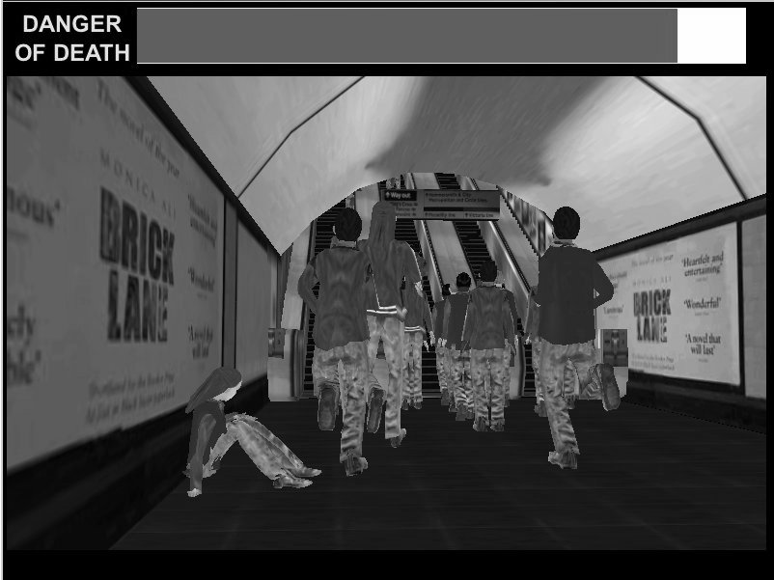
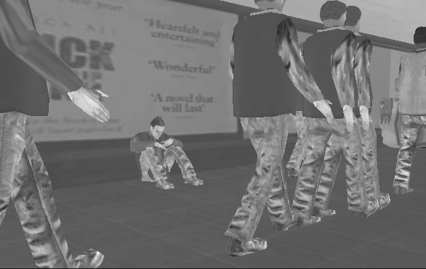
In order to achieve the real-time rendering of the world it is necessary to use a technique called low-polygon modelling. Where, in reality, objects are made up of a lot of very fine detail in terms of their shape, it is often possible to reduce this complexity by ignoring intricate details. Neglecting fine detail reduces the realism of the world, but increases the ability for a computer to process the positions of the hundreds of thousands of polygons and render them to the screen. Taking a low-polygon model, and texturing it using digital images, which can be cleverly mapped to the faces of the object, can replace the information lost in simplifying the mesh. This gives the look of a detailed model, whilst retaining relatively low-computational requirements.

Modelling of Crowd Movements
The members of the crowds in the current simulation currently move on fixed paths which are rigidly controlled by the program code. Future developments of the software are intended which will incorporate Discrete Element Method (DEM) techniques to control the flow of the crowd members. A number of two dimensional models have been tested which give each discrete element (person in the crowd) a set of rules which define its movements in relation to obstacles and other crowd members. This technique offers the exciting potential to include the psychology of individuals into large scale crowd modelling. An example image of one of the test emergency evacuations based on DEM techniques is shown above.
Contacts
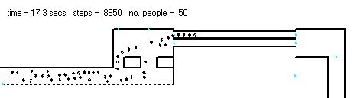
Dr Andy Burton  amb@cs.nott.ac.uk  http://www.cs.nott.ac.uk/~amb  Mixed Reality Laboratory,  School of Computer Science and IT  University of Nottingham  NG8 1BB, UK | Dr Damian Schofield  damian.schofield@nottingham.ac.uk  http://www.cs.nott.ac.uk/~dzs  Mixed Reality Laboratory,  School of Computer Science and IT  University of Nottingham  NG8 1BB, UK | Dr Paul Langston  paul.langston@nottingham.ac.uk  http://www.nottingham.ac.uk/scheme/staff/langston.htm  School of Chemical, Environmental  and Mining Engineering (SChEME)  University of Nottingham  NG7 2RD, UK

Shrek copyright Dreamworks (2001), The Incredibles copyright Pixar (2004)

